EE 480-HOMEWORK 6

Question 1: Give specific details for using the RPi's GPIO as digital outputs and digital inputs.

The row of GPIO (General-Purpose Input/Output) pins along the top edge of the board is a powerful function of the Raspberry Pi. All existing Raspberry Pi boards feature a 40-pin GPIO header (unpopulated on Pi Zero and Pi Zero W). A shorter 26-pin header was composed of boards prior to the Pi 1 Model B+ (2014). Any of the GPIO pins may be marked as an input or output pin (in software) and used for a wide variety of purposes. 3.3V logic levels are used by the Raspberry PI GPIOs and are directly connected to the Microprocessor chip. Therefore, it is a bad idea if these pins are connected to 5V or higher without level conversion circuitry (transistor switch) as it will damage the Pi.
To switch an electrical circuit on or off, a GPIO can be used as a digital output. This example uses an LED, but the concepts hold true for any sort of circuit; you might also use a relay to switch high-powered devices on/off, for instance. To ensure that you don't draw too much current from a GPIO, circuits are given. Code examples are designed to make the interfacing of software easy and effective. A GPIO pin designated as an output pin can be set to high (3V3) or low (0V).
It is possible to read a GPIO pin designated as an input pin as high (3V3) or low (0V). With the application of internal pull-up or pull-down resistors, this is made simpler. GPIO2 and GPIO3 pins have fixed pull-up resistors, but this can be set up in software for other pins.

Question 2: Describe the importance of pull-up and pull-down resistors as they relate to using the RPi's GPIO pins.

Pull-up and Pull down resistors are used to correctly bias digital gate inputs to prevent them from spontaneously floating when there is no input condition. With floating we refer spontaneous radiation and electromagnetic signals from the environment are captured by the pin and any wires linked to it. It is not HIGH or LOW when the circuit is open, but somewhere in between.
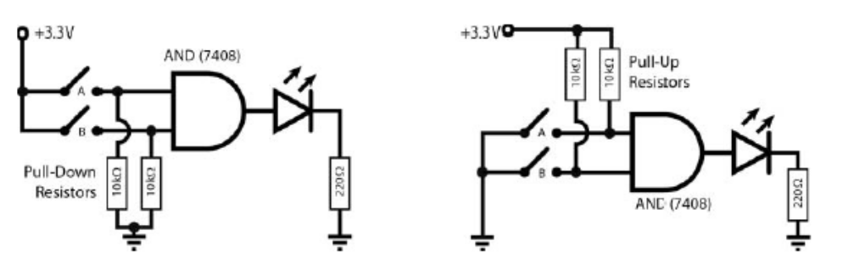

As the figure above shows, you can use pull-up or pull-down resistors to stop floating inputs. Pull-down resistors are used if you want to guarantee that when the switches are open, the inputs to the gate are low, and pull-up resistors are used if you want to ensure that when the switches are open, the inputs are high.
The resistors are necessary, because if they were removed and replaced with wire lengths, when the switch is closed, the switch would form a short circuit to the ground. Also critical is the size of the pull-down/up resistors; their value must be low enough to pull the low/high input firmly when the switches are open, but high enough to stop too much current flowing when the switches are closed.
Ideal logic gates have infinite impedance and will be sufficient for any resistor value (short of infinite). Real logic gates, however, leak current and you must solve this leakage.
You should select the maximum value that actually draws the low/high input in order to minimize power consumption. A 3.3 k-10 k resistor normally works well, but when the switch is closed, 3.3 V can push 1 mA-0.33 mA through them respectively and dissipate 3.3 mW-1 mW of power respectively. You could test larger resistors of 50 k or higher for power-sensitive applications.

Question 3: Complete the An Enhanced GPIO Class section in chapter 6, pages 242 - 244. Copy the results of the test for your answer and give a picture/video of your program as it executes.

To make it easier to use, a C++ class has been written that wraps the GPIO functionality of sysfs on the RPi. The importance of this approach is that it is transferable to any Linux system that is embedded. The class is extensively discussed in chapter 5, however in chapter 6 GPIO classes tend to be complex and difficult to comprehend.
Test circuits are incorporated to enhance and simplify GPIO class, in this case the class code is efficient and executes faster. Test circuit is a combination of LED circuit and Button circuit
This code's response time is captured in the figure below. Since the polling is done effectively by the Linux kernel, this code runs with a 0 percent CPU load. The electrical response time is determined using an oscilloscope between the first rising edge of the button press and the turning on of the LED.
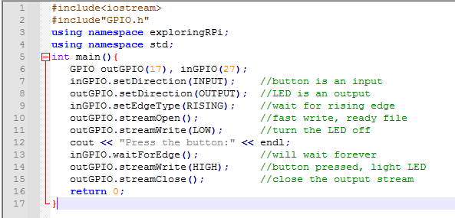
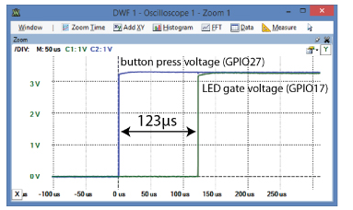
This program responds to ~123 μs in physical debounce filter cycles, which is fine. This output will not be influenced by the use of the class's debounce filter, only the delay between repeated button presses. The downside to this code is that when awaiting the button press, the software will not perform other operations. Further we can enhance the code with the waitForEdge() method which permits function pointer and allows the use of Pthreads to allow the program to continue with other operations.
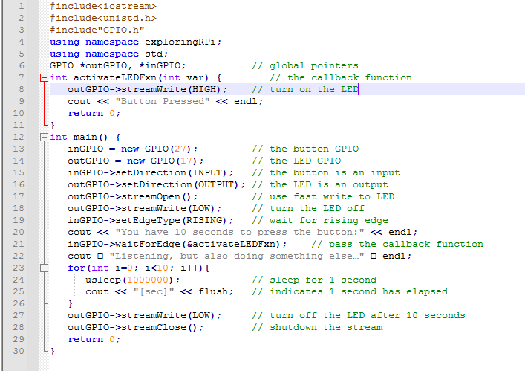

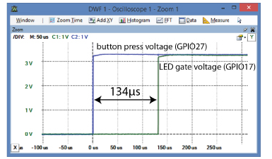

The significant difference in this code is that a new thread is generated within the method when the setEdgeType() method is called, and it restores control immediately so that the main thread can continue performing operations. Before turning the LED off, the key thread simply counts for ten seconds. The activateLED() function is called if the button is pushed. The LED will be switched off whether or not the pushbutton is pushed, and the program will exit after 10 seconds of counting:

Question 4: Complete the WiringPi section in chapter 6, pages 252 - 259. Copy the results of the test for your answer and give a picture/video of your program as it executes.

WiringPi is a C-written library used to access GPIO pins for BCM2835 (Broadcom Processor) SoC pins on Raspberry (System on Chip). Different libraries like bcm 2835, sysfs, pigpio, etc. are available to access GPIO in C. WiringPi is a core C library, but it is open to both Ruby and Python users who can either "gem install wiringpi" or "pip install WiringPi". In the end, the WiringPi-Python library eventually adds to Python a whole host of current WiringPi features, including brand new features from WiringPi 2. WiringPi uses its own pin numbering system, here you can learn how your GPIO pins are numbered by WiringPi, what those pins do and how to do shiny stuff from inside Python or Ruby with them.

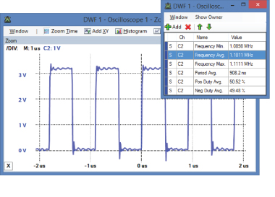
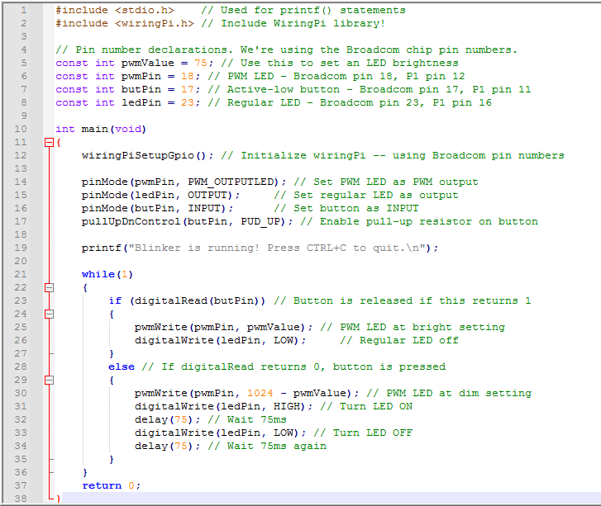

Question 5. Complete the PWM Application - Controlling a Servo Motor section in chapter 6, pages 266 - 268. Copy the results of the test for your answer and give a picture/video of your program as it executes.

Servo motors have long been around and are used in many applications. They are small in size, but they are very energy-efficient and pack a big punch. These features allow them to be used to in remote controlled robots and radio controlled devices. Servo motors are also used in industrial applications, in-line processing, robotics, pharmaceuticals/ medicine and food services.

Servos are operated by sending through the control wire an electrical pulse of variable duration, or pulse width modulation (PWM). A minimum pulse, a maximum pulse, and a repetition rate are present. For a total movement of 180 °, a servo motor may normally only turn 90 ° in either direction.

The neutral position of the motor is defined as the position where, in the clockwise or counter-clockwise direction, the servo has the same amount of potential rotation. The position of the shaft is determined by the PWM sent to the motor and is dependent on the length of the pulse sent through the control wire; the rotor will switch to the desired position.

The servo motor expects to see a pulse every 20 milliseconds (ms) and how far the motor turns will be determined by the duration of the pulse. For eg, a pulse of 1.5 ms would transform the motor to a position of 90 °. It pushes it towards the 0 ° position in the counter clockwise direction shorter than 1.5ms, and the servo will turn towards the 180 ° position in a clockwise direction no longer than 1.5ms.
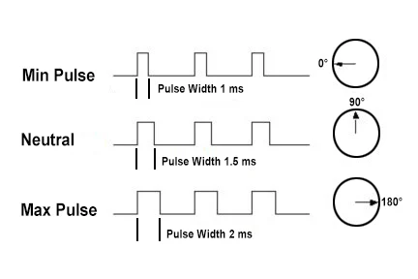
// Listing 6-17: /chp06/wiringPi/servo.cpp
